PERSONAL INFORMATION | Filip Alexandru Emilian
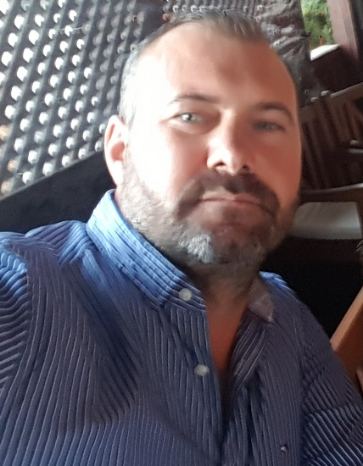 |   Garii, 33, Costinesti, 907090, Romania

 0040765865216

Zeulmarii81@gmail.com
 | Sex Masculin | Date of birth 04/08/1981 | Nationality Romanian

JOB APPLIED FOR  POSITION  PREFERRED JOB | Chef

WORK EXPERIENCE |  |  |  | faf
Period
Occupation or position held

Name and address of employe | April 2012 - May 2014  Chef at Cherhanaua Vadu with fishery specific  Preparation of the menu  Preparation of food according to the recipes given  Prepare several dishes at the same time, depending on the order  Arranging and decorating food before being served on plates / bowls / trays  Ordering, testing and receiving and storing food ingredients  Maintenance of tools and equipment  Pre-processing for cooking: sorting, cleaning, washing, cooking, boiling, frying, baking and frying foods  Performing other tasks assigned by the chef  Cornus Ion-owner Cherhanaua Vadu, from Vadu  June 2009 - January 2012  Greek restaurant chef "Bistro Papa's"  Greek Bistro Papa's Restaurant in Bonnigheim, Germany  Gastronomy  November 2005 - December 2007  Help - Chef at the French restaurant “La Poissonnerie”  French restaurant "La Poissonnerie" in Lyon, France  Gatronomie
Name and address of employe | February 2015 - April 2018  Executive Chef at the "Beluga" Restaurant with fishery specific  Coordination of the entire activity in the restaurant kitchen  Managing all types of resources that make a kitchen work: people, appliances, raw materials  Relationship with suppliers: tracking prices, negotiating them and choosing products regarding the quality / price ratio  Creating the menu  Organization of personnel activity  Cooking specific food for the restaurant  Prisacaru Dan - Owner Restaurant with fishery specific "Beluga", from Mamaia resort  Gastronomy  October 2014 - January 2015  Chef at "Ankora" Restaurant with Italian style  Preparation of the menu  Preparation of food according to the recipes given  Prepare several dishes at the same time, depending on the order  Arranging and decorating food before being served on plates / bowls / trays  Ordering, testing and receiving and storing food ingredients  Maintenance of tools and equipment  Pre-processing for cooking: sorting, cleaning, washing, cooking, boiling, frying, baking and frying foods  Performing other tasks assigned by the chef  Munteanu Daniel- owner of Italian restaurant "Ankora", Constanta tourist port  Gastronomy  June 2014 - October 2014  Chef at "Crazy Beach" Restaurant with Mediterranean-international character  Preparation of the menu  Preparation of food according to the recipes given  Prepare several dishes at the same time, depending on the order  Arranging and decorating food before being served on plates / bowls / trays  Ordering, testing and receiving and storing food ingredients  Maintenance of tools and equipment  Pre-processing for cooking: sorting, cleaning, washing, cooking, boiling, frying, baking and frying foods  Performing other tasks assigned by the chef  Ghiuri George Orlando - owner of Mediterranean-international restaurant "Crazy Beach", from Mamaia resort  Bobes Horatiu - “Crazy Beach” restaurant manager  Gastronomy
Name and address of employe | April 2018 - August 2019  Executive Chef at the "Black Sea" Restaurant with fishery specific  Coordination of the entire activity in the restaurant kitchen  Managing all types of resources that make a kitchen work: people, appliances, raw materials  Relationship with suppliers: tracking prices, negotiating them and choosing products regarding the quality / price ratio  Creating the menu  Organization of personnel activity  Cooking specific food for the restaurant  Making the menu  Balan Alexandru - administrator / owner Restaurant with fishery specific "Black Sea", from Costinesti
Name and address of employe | Executive Chef at the Toscana Restaurant with Italian specific  Coordination of the entire activity in the restaurant kitchen  Managing all types of resources that make a kitchen work: people, appliances, raw materials  Relationship with suppliers: tracking prices, negotiating them and choosing products regarding the quality / price ratio  Creating the menu  Organization of personnel activity  Cooking specific food for the restaurant  Making the menu  Ovidiu Iacob - administrator / owner Restaurant Toscana Constanta

EDUCATION AND TRAINING
Period 2007-2009
Qualification / diploma obtained -
The main disciplines studied Economy, Tourism
Name and type of educational institution
Spiru Haret University, Constanta, Tourism Department
The level in the national or international classification Higher Education
during 2002-2005
Qualification / diploma obtained Diploma

The main disciplines studied Economy and tourism
Name and type of educational
institution Mangalia Economic College, Mangalia
Level in national or international
high school classification

period 1997-2000
Qualification / diploma obtained Diploma Baccalaureate
The main disciplines studied / acquired professional skills Public food and tourism

Native language (s) Romana

Foreign language (s) English
understanding Speaking
European level (*) Listening Reading Participation in the conversation Oral speech
English C2 C2 C2 C2
French language C2 C2 B2 B2

Social skills and abilities Orientation to results, flexibility, communicativity, stress and new resistance, good memory.

Driving licence | :  B

